The Near

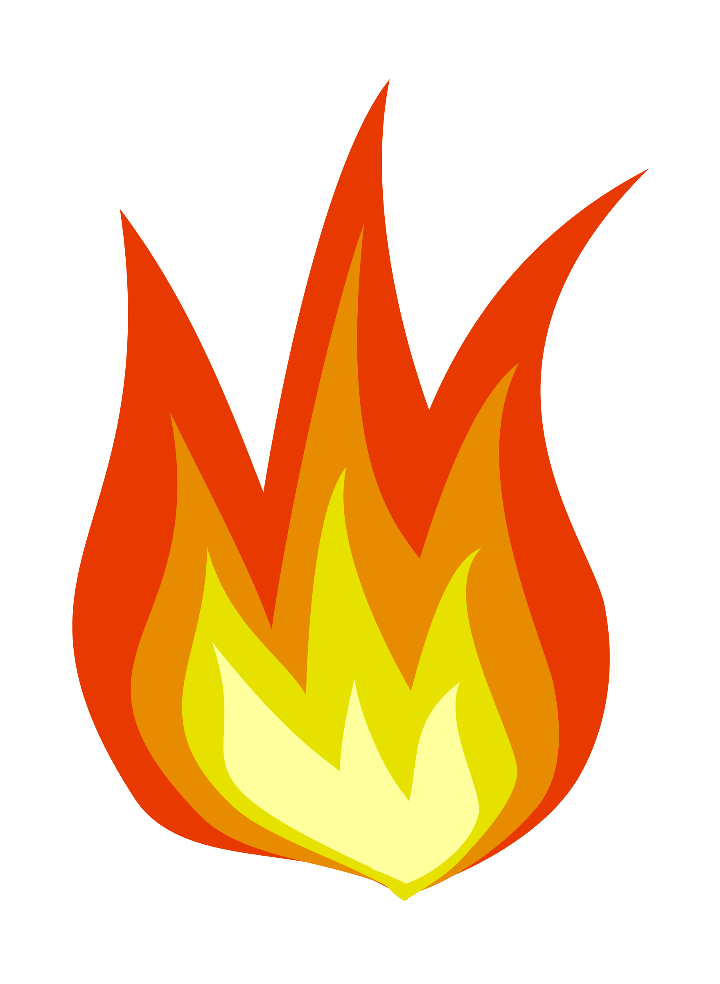

True News

The Near

True News

**The Near**

**True News**

The Near

True News

The Near

True News

The Near True



News

**The Near**

**True News**